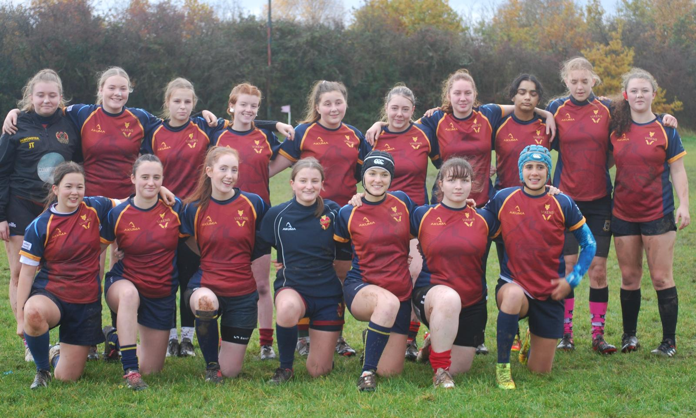
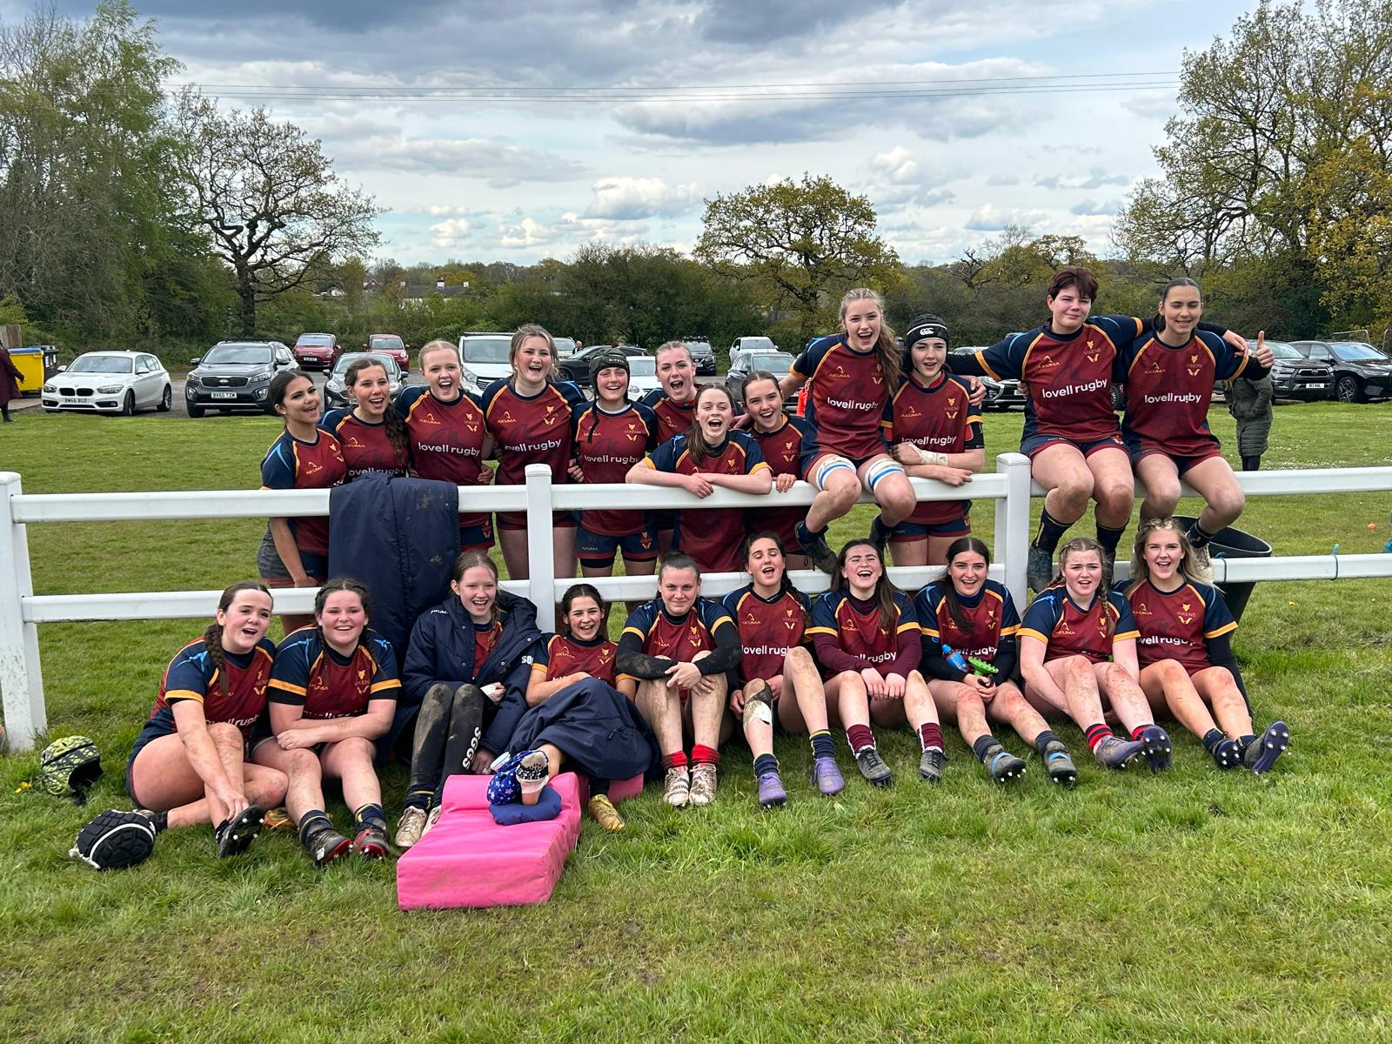

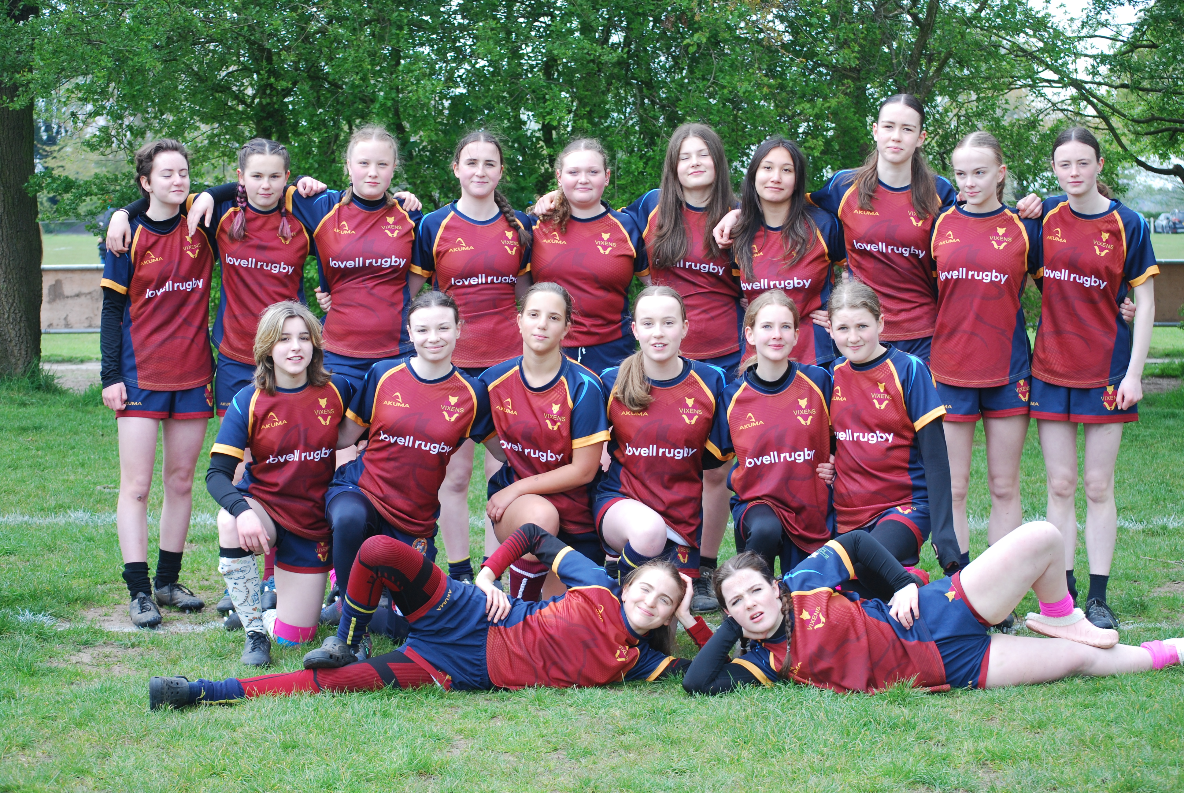
Welcome to the team!

How To Be A OY Vixen
  - Old Yardliens Vixens
First things first….. these are the key things you need to do:
 | Download the SPOND app – this is how we organise ourselves for training and match availability
 | If you haven’t already got it, download WhatsApp too – this is how we communicate general info, either at team or Vixens community level
 | Register your Vixen on the RFU Game Management System: https://gms.rfu.com/GMS/Home/Start
 | Complete this form, so that we have your details in case we need to contact you urgently
 | We’re active on Instagram here
 | We’re active on FaceBook here
 | We’re active on TikTok here

Your team manager will add you to the relevant SPOND and WhatsApp groups, and can help you with your GMS registration:
 | U14 – Charlie:  07813 838 736 | U16 – Emma:  07861 294534 | U18 – Georgina:  07825 710 112

Kit  We provide each Vixen with a playing shirt and have an online shop available to purchase other kit. There is no requirement to wear branded kit for training. Your Vixen will need a gum shield and boots.  We also have a kit swap in place so before you buy anything, please ask for Robin who can check if there’s anything suitable for you in our community.  We also have 5% discount available from Lovells who are one of our sponsors. Please ask for details. |  | 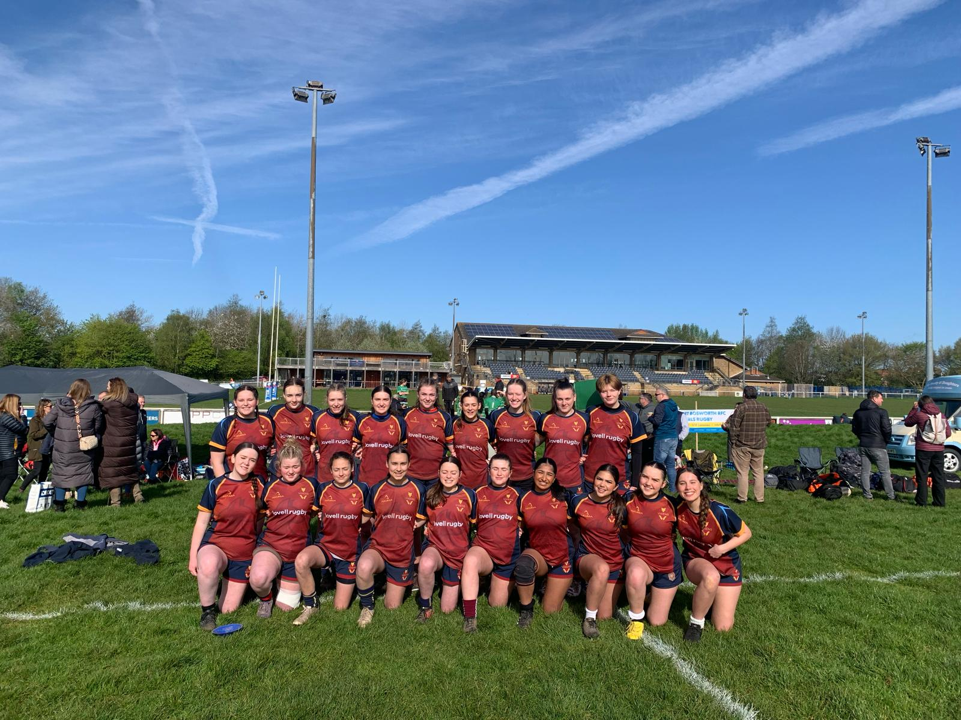
 |  | Safeguarding & First Aid  Every age group has at least one qualified first aider at every training session and match.  We track any injuries via an accredited app, which means that we can also track return to play protocols in the event of head injuries.  We also have a safeguarding liaison manager, Rachel.
When & Where  U12s to U16s train every Wednesday evening and Sunday lunchtime (if no match). Matches are on Sunday afternoons. U18s train on Tuesday & Thursday evenings.  Locations can vary, so please check SPOND for details for each session. |  | 
 |  | Expectations  Rugby’s values of Teamwork, Respect, Enjoyment, Discipline and Sportsmanship are what makes the game special for those who enjoy the environment and culture they create.

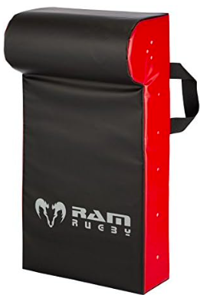 |  | Costs  We rely on subscriptions, sponsorship and fund raising to ensure we have the right equipment for all of our age groups.  The annual subscription is variable depending on which club your Vixen becomes a member of. It is approximately £80 per year and we can advise which club to join based on where you live. Every player has to be a member of an accredited RFU club.  We fund raise thoughout the year, normally via social events, such as the Christmas party and end of season awards.

